Net_Command

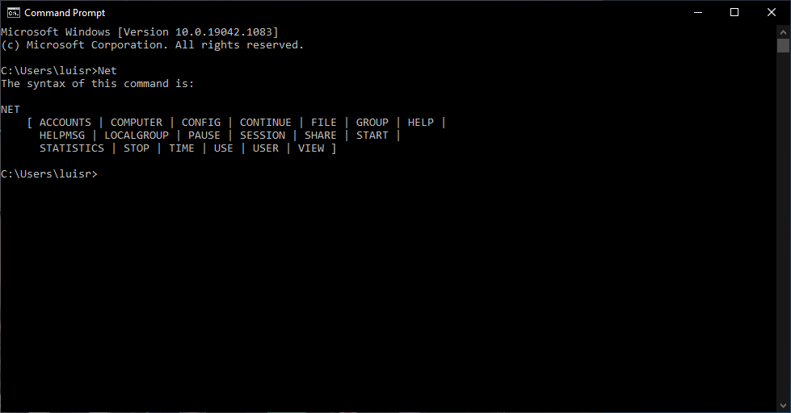

Net_Share on both Folders

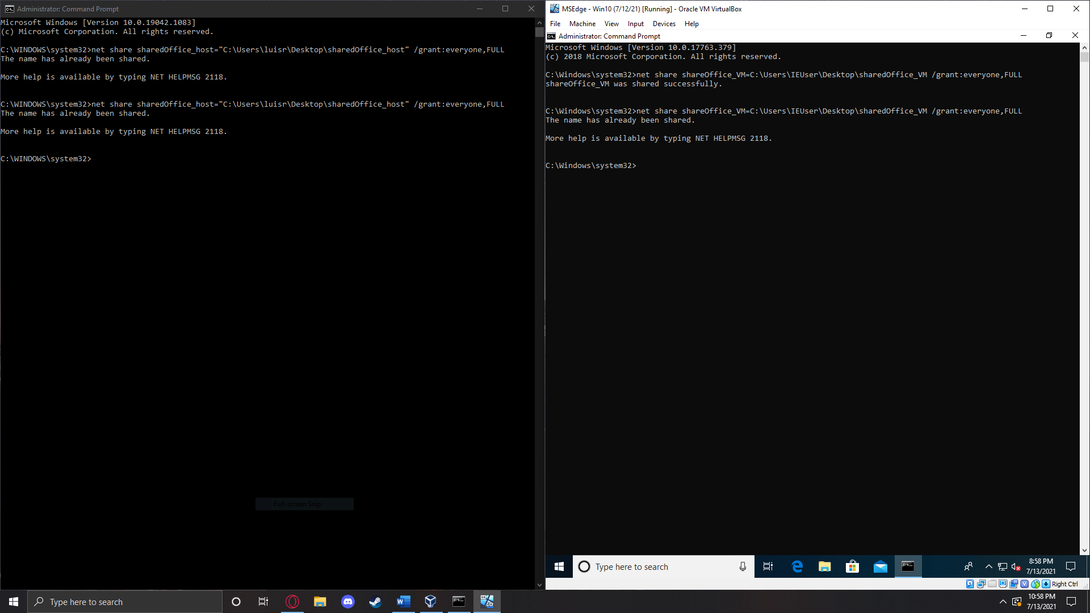

Share_Folders

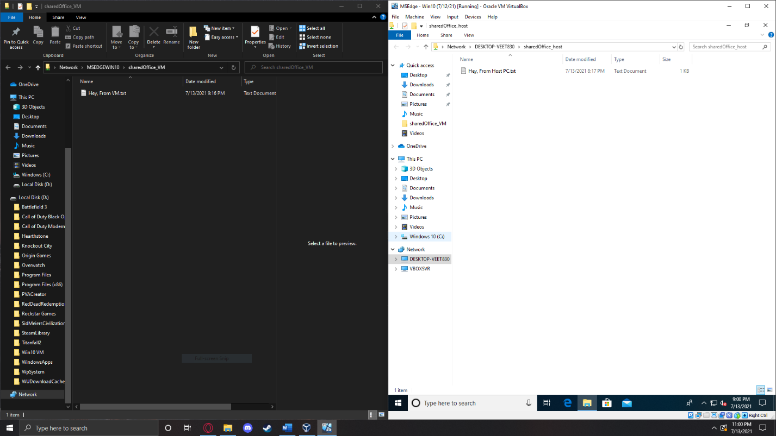

Questions:

Why you need to use professional versions of windows when connecting to the server.

**It would allow for a better UI when working on network and make the job processes a lot easier in the long run.**

If you are only connecting two computers there is no need for a switch. Explain how this can be accomplished.

**Just use cross-over cable to get the job done since all you are doing is connecting the two PC. Switch is only needed when you are working with multiple.**